SED Stream Editor
Use sed (stream editor) to transform text as it flows through the command line.
The word "stream" matters here. sed was designed for situations where text moves through commands line by line, not just for manually editing a file in a screen editor. This reflects an old but powerful Unix philosophy: many tasks can be automated by transforming text in pipelines.
Substitute text.
Delete lines.
Mask sensitive data.
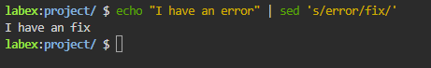
Delete Lines (d)
Delete the first 5 lines of data.txt.
First, check file content > Then, delete lines 1-5
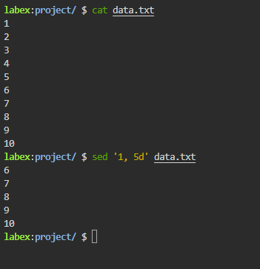

Mask Sensitive Data
Replace all usernames in users.txt with USER. The file has lines like User: alice connected. We want User: USER connected.
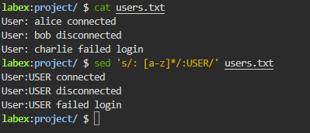
[a-z]*: Matches any lowercase name.
: USER: Replaces the match with generic text.
The names alice, bob, and charlie are now hidden

